Jason Silva
MWF
Final Draft
From the birth of Afghanistan up until 1973, the country was ruled by a monarchy. In 1973, a bloodless coup occurred; people enjoyed about six years under a “fair” ruler. However, insurrections occured, as not everyone was yet satisfied. On Christmas Day in 1978, the tides turned and the Soviets invaded Afghanistan to quell the chaos (Truman, unknown). This, however, only helped to create more chaos and turn the eyes of the rest of the world toward Afghanistan. This, was the start of toward progressive movement in Afghanistan.
Afghanistan is one of many countries trying to understand where its boundaries lie. The Afghan people hold religion high, but are also accepting of Western influence. The climate is desert-like, although within the cities Afghans are renowned for growing potatoes and pomegranates. Cities are built to the point where skyscrapers paint the horizons and motorized vehicles are an incoming method of transportation. And while religion is honored, and can be seen everywhere in public. As can its opposition, Progressivism-the general political philosophy advocating or favoring social, political, and economic reform. Traditionally women must always wear a burqa in public, and if it is removed, taliban religious police use rigorous violence to discipline her. Yet, women continue to protest, by letting some hair out or removing a burqa entirely (Griffin, 2009).
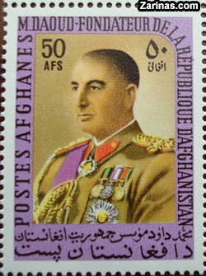
This sign of protest is, although recent, certainly not the first sign of progressive ideas. Afghan progressivism isn’t as old as progressivism in most parts of the world. The fight, however, is just as strenuous and eventful as any other country. The first and most impactful progressive movement was the coup of 1973. The Coup remained bloodless, and so to an extent remained progressive (as opposed to a revolution). The country’s political structure changed from a monarchy to a presidency, under the rule of president Daoud Khan. After six years, this regime was overthrown with Daoud’s assassination by a revolutionary Marxist group known as the PDPA (People’s Democratic Party of Afghanistan). They began dismantling the governing head, while implanting their own progressive ideas such as women’s rights (they introduced women to politics). However, an opposing progressive group known as the Mujahideen began to rebel against the PDPA; the PDPA called in the Soviet’s for support (Wikipedia, 2012)
Figure 1
The Soviet War in Afghanistan is one of Afghanistan’s most significant event in the Progressive movement. The PDPA was pushing for a more Marxist society; the Mujahideen wanted a democratic nation. The Soviet War pushed into the late 1980s, and ended with the retreat of the Soviets. Progressivism was intricately woven into the war, and each side fought to harm the momentum of the other. The Soviets planned to put the PDPA in power, but to do so they would have to quell the Mujahideen. The Mujahideen, on the other hand, elected Democracy as the guiding goal, and were able to call on the support of the U.N. and U.S.A.
Of course, the mujahideen and allied armies fought for the rights, but the rights they fought for came from the people. Focusing on the Mujahideen, traditions of people supporting Democracy were beginning to be broken. One such tradition is when a son is born, the father rushes into the street with his pistol and fires a few rounds into the air to celebrate. When Saima Wahab was born, her father did the same thing, promising that his daughter would prove that she is better than many Pashtun sons (Wahab, 2012). Although the PDPA believed in some women’s rights, they did not tolerate these sorts of changes, and Saima’s father was taken away by the KGB, never to be seen again.
The Soviet War ended in the late 1980’s, when the Afghan people began building democratic structures of government.
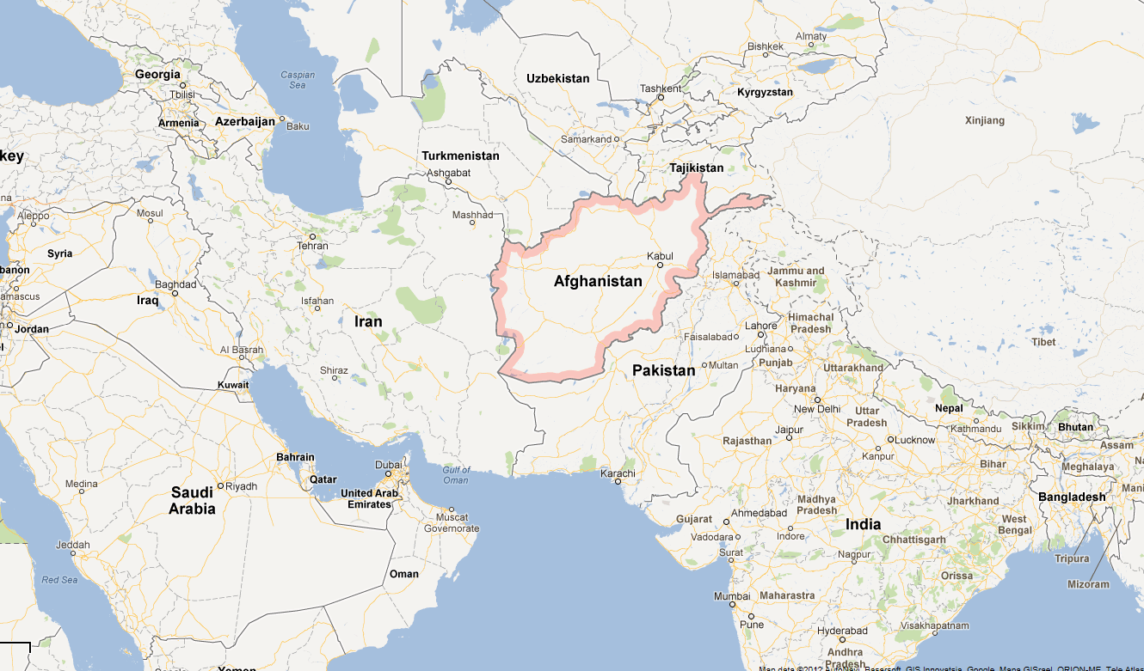
(Google, 2012) Afghanistan is surrounded by neighbors such as Pakistan, Iran, and Tajikistan. The Taliban began to regroup in Pakistan, one of the many reasons President Bush sent American troops into Afghanistan. Iran is considered a threat to the United States with the pursuit of a nuclear program, which reflects poorly on the Middle East as a whole. It’s sad to say, but every time the Middle East is mentioned, common citizens immediately think of violence and terrorism. Anyone who speaks out against the tyranny of the Taliban, including most recently 14 year old Malala Yousafzai, who spoke for peace.
Figure 2
Figure 3
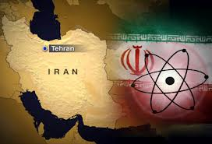
Despite these negative influences, Afghanistan perseveres in Progressive ideals. The Arab Spring that began in 2011 with Egypt has spread and taken hold in Afghanistan. The government and army of Afghanistan is slowly beginning to repel the Taliban. The young Malala is recovering as thousands rally in her support. The Taliban is scared.
There is hope for progressive ideals in Afghanistan. The biggest question is what is: needed to continue supporting this movement? America has plans to pull their troops out of Afghanistan by the year 2014. This is expected by the U.N. Will the Taliban attempt to regain the control they’ve lost? Will Iran’s constant pursuit of nuclear arms trigger another global war that could halt the change that has been made? The government and army of Afghanistan has grown stronger; more people have united against the Taliban and are not afraid to stand up against them. The signs show a future of struggle, but still an optimistic future for Afghanistan.

Reference Page
- Google. (Photographer). (2012). Map of the world. [Web Photo]. Retrieved from https://maps.google.com/maps?oe=&q=afghanistan&ie=UTF-8&hq=&hnear=0x38d16eb6f8ff026d:0xf3b5460dbe96da78,Afghanistan&gl=us&ei=Qc9oUJCVBqjaywGTk4HQBg&ved=0CH0QtgM
- Griffin, R. (2009, April 07). [Web log message]. Retrieved from http://blog.peaceactionwest.org/2009/04/07/a-message-to-progressives-on-afghanistan-part-2-womens-rights/
- Trueman, C. (date unknown). Russian invasion of Afghanistan. Retrieved from http://www.historylearningsite.co.uk/russia_invasion_afghanistan.htm
- Wahab, S. (2012). In my father's country: An afghan woman defies her fate. New York: Crown Publishers
- Wikipedia. (2012, September 30). Soviet war in Afghanistan. Retrieved from Encyclopedia, B. (unknown date). Soviet invasion of Afghanistan. Retrieved from http://www.britannica.com/EBchecked/topic/1499983/Soviet-invasion-of-Afghanistan

