Jason Silva
Eng. 2010
MWF
In this day and age, it’s very likely you’ve heard of Afghanistan. When you hear the word Afghanistan, one of two things comes to mind. The first is terrorism whether or not the protest group is Al Qaeda, the Taliban, or McDonalds. The second is the United States involvement in Afghanistan. The current plan is to have fully withdrawn from Afghanistan by the year 2014. These issues aren’t the only matters Afghanistan should be known for. Like all other countries, Afghanistan changes, grows, mourns and celebrates. One aspect that has also changed is Afghanistan’s society has undergone progressive reform. Please continue reading to watch a new country unfold.
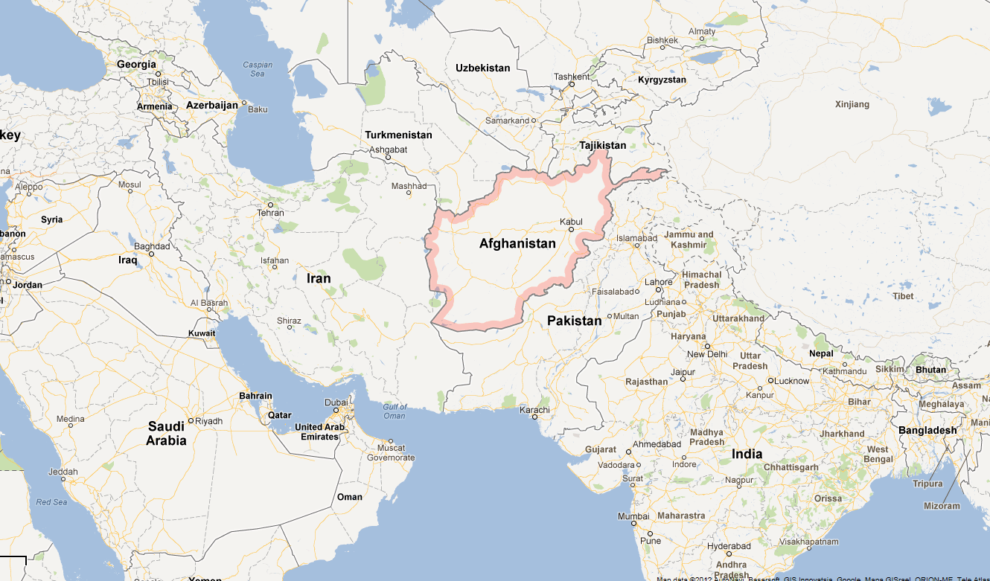
All stories have a beginning. Ours begins in Afghanistan which is located in the Middle East.
Figure 1
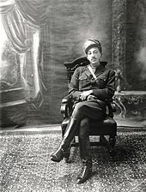
While the entirety of Afghanistan’s history is necessary, we need to jump back a couple decades to see the birth of Progressivism in this country. Since the birth of the country, Afghanistan was ruled by a monarchy, traditionally headed by a king. This tradition led up to the year 1973, where the last King, King Zahir Shah, who was overthrown in a bloodless coup led by his cousin Prime Minister Mohammed Doaud Khan- while he was overseas. This was the first step toward greater political freedom, Zahir’s uncle Mahmud Khan had wanted to take in 1946.
Figure 2
Mohammed Doaud Khan had always sought a closer relation with the Soviet Union although Afghanistan remained neutral before his reign. Doaud Khan led his people for five years until he and his family were assassinated in 1978 in a Marxist revolution. The revolution was led by the People’s Democratic Party of Afghanistan (PDPA). The PDPA, once they held power, immediately captured and tortured elite members while prohibiting usury, declaring equality of the sexes, and introducing women to the political world. This was a rather controversial yet major step of progressivism.
This step stumbled into confusion, however, as later in the year a force known as the Mujahideen began to rebel against the PDPA. This struggle caused incredible turmoil and chaos in Afghanistan for a year and caused the Soviets to intervene on December 24, 1979. For almost ten years the Soviet Union & PDPA fought against the Mujahideen with no success. Often, as well, the Soviets caused unwanted trouble such as when they bombed villages in Iran who suspected that they hid Mujahideen soldiers (this led to several aerial battles between Iran and the Soviet Union). In 1989 the Soviets withdrew, and the Mujahideen were able to secure a more democratic government. This was the second and likely greatest step in progressivism in Afghanistan.
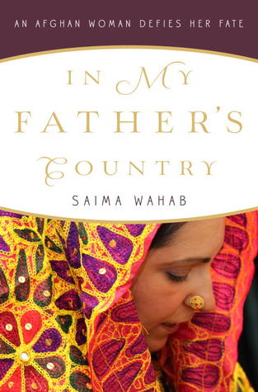
Of course, this was all on a national level. A government is nothing without its people. The smaller communities within Afghanistan saw their share of progressive ideals and movements, some of which held power within national matters. In My Father’s Country: An Afghan Woman Defies Her Fate shows a prime example of this. When Saima was born, she “… was welcomed into this world with gunshots. In Afghanistan, when a son is born, tradition dictates that the father rushes into the street with his pistol and fires a few rounds into the air to celebrate…. Minutes after I was born, my father rushed outside with his weapon and did the same”(Wahab, 2012). Saima was born in the year 1976, when President Mohammed Doaud Khan was still leading the country. Progressivism had started, but it wasn’t as far as it would be only three years later. Saima’s father, shooting guns at the birth of his daughter, knew “…my daughter will prove that she is better than many Pashtun sons, and will do more for her people than one hundred sons combined!” (Wahab, 2012).
Figure 3
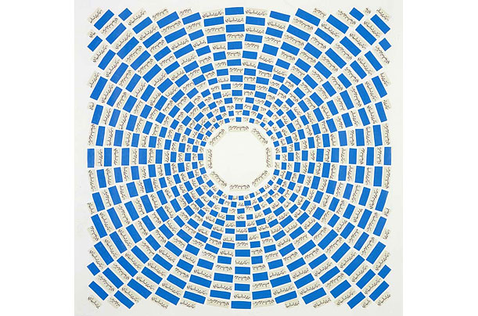
Does Afghanistan continue to progress or has the momentum of the late 80’s been lost? Within the last decade, Afghanistan has seen more trouble than it wanted to deal with; surprisingly, they still manage to progress. Towards 2002, the Taliban were beginning to withdraw from many other countries-including Afghanistan- to regroup in Pakistan. Because of this, the government of Afghanistan was able to begin rebuilding the war-torn country. Afghanistan made progress in education, in their economy, health, and government; other things like transportation and agriculture. However, it wasn’t 100% peace in Afghanistan even with the Taliban retreating for the time being.
Figure 4
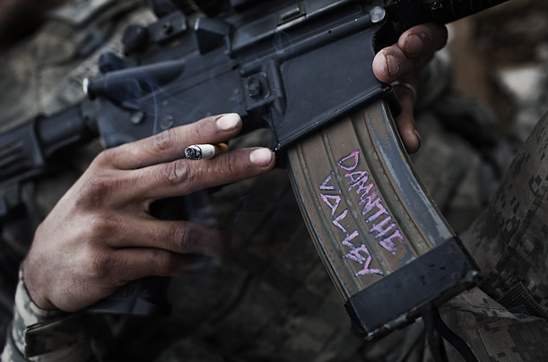
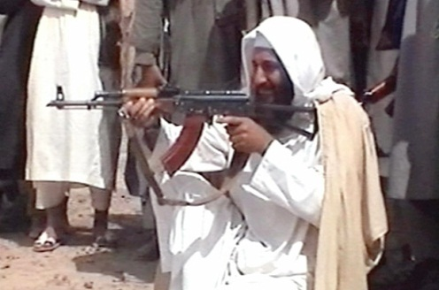
For instance, the U.S. was stationed in Afghanistan fighting the Taliban who were still there. While the whole story is too long to tell (eleven plus years long), some brief details are beneficial to an understanding of the circumstances. After the terrorist attack on the Twin Towers on September 11, 2001, President Bush declared war on terror. Within months, troops were sent to overthrow the regime of the Taliban and prevent the destabilization of Pakistan. The first matter was settled in three months. A second fear has become America’s largest foreign policy challenge and kept America involved for 7 years. In 2008, President Obama admitted more troops to Afghanistan “to disrupt, dismantle and defeat al-Qaeda in Pakistan and Afghanistan and to prevent their return to either country in the future” (Baker, 2009). This gained a major step on May 2, 2011, with the death of Osama Bin Laden. Unfortunately, this path is laden with hard struggles for the brave soldiers positioned there. This is where I need to make a point astounding to most readers. Afghanistan did in fact progress with the help of Osama Bin Laden. At this point only half of you are still reading, so allow me to clarify. As mentioned earlier, the Soviet Union “invaded” Afghanistan. During this war, Osama Bin Laden set up training camps for the Mujahideen. In fact, in Figure 6 the gun Bin Laden is holding is a Kalashnikov Rifle he took from a Russian soldier he killed during the Soviet War (Press, 2011). Even after the war, Bin Laden continued to raise money for the Mujahideen, and sent heavy equipment for the building of roads, tunnels, and bridges. After his exile, he established Al Qaeda, meant to offer religious training to the Mujahideen. However, Al Qaeda soon became labeled a terrorist group, which led to the many fights until his death in May 2011.
Figure 6
Figure 5
Osama Bin Laden did many bad things, but it must be realized he was still human. He had children he loved, several wives by his side, and faith in his belief even to the point where he accepted his label as a terrorist; “If the instigation for jihad against the Jews and the Americans in order to liberate al-Aqsa Mosque and the Holy Kaaba is considered a crime, then let history be a witness that I am a criminal” (Corbis, 2011). This is not to make him out as a hero or search for empathy or a change of heart; and there is no denial that the countless deaths at his hands were beyond criminal, but he still had some heart. “After Bin Laden's death, it was reported he had left a will written a short time after 9/11 in which he urged his children not to join al-Qaeda and not to continue the Jihad”. (Black, 2011).
To close, the question asked earlier was: The United States has pledged to pull remaining soldiers in Afghanistan pulled out by 2014. The Afghan army and government has become strong enough to handle themselves. The culture, society, and structure of Afghanistan does indeed continue to grow. There is progressivism in Afghanistan, and hopefully like those countries who had it before them, it’ll be there in the future.

Jason Silva
English 2010
MWF
Progressivism has always been seen as a very liberal ideal. In fact, oftentimes liberal and progressive are used interchangeably (whether they should be or not is a different argument). When someone says progressivism, the first thing to come to mind usually is a movement towards democratic ideals or a democratic system of government. This is no different for Afghanistan, although there was little to no evidence of progressive movements until the coup d’état that overthrew the king. (wiki, 2012) From there, Afghanistan witnessed rapid progression through trial and wars. Today, there is strong evidence to support the progressive momentum that will continue for some time.
There are those who say the Afghan progressive momentum is not accomplishing much. Dissention begins by referring to the current state of the country. Most Americans know about the U.S. involvement (a.k.a. War) in Afghanistan. In 2001, President George W. Bush, driven by the September 11 attacks, ordered U.S. troops into Afghanistan with the goal of dismantling the al-Qaeda terrorist organization. The U.S. was able to disrupt the al-Qaeda structure by the end of 2002, but the Taliban led insurgencies periodically. In 2006, NATO became involved and, in 2009, the U.S. sent even more troops into the area (Musadeq, 2012).
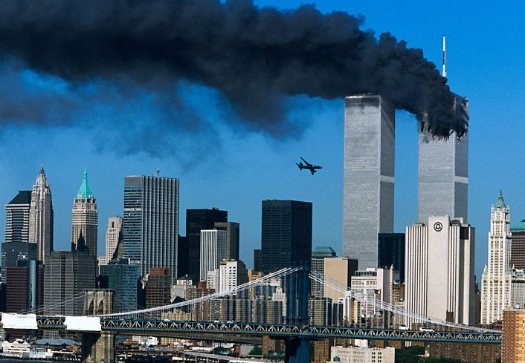
Nine years after the U.S. sent troops to Afghanistan, the war was beginning to turn in favor of the U.S. The U.S. and British sent a joint coalition of troops. With this surge of troops, peace initiatives began to unfold with Pakistan. The next year, close to a decade after the 9/11 attacks, President Obama sent Seal Team 6 who successfully killed Osama Bin Laden—a major turn-around in all the years of war. (Baker, 2009) The Afghanistan government has begun to regain control within their country. At the 2012 U.N. meeting, the U.S. stated they planned to withdraw all U.S. troops by the year 2014.
Figure 1
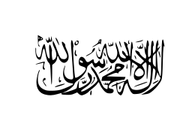
Many Americans believe the U.S. didn’t need 10 years of war with Afghanistan. This leads to the argument that is too war torn to recover. While it is true that since the coup of 1973, Afghanistan has seen war in its country, they have slowly been building and growing ever since the Soviet Union retreated in the late 1980’s after their invasion. The presence of al-Qaeda and the Taliban started strong, but has steadily decreased with help of the U.N. and the rise of the Afghan governmental power. It’s also reported that more Afghan citizens/refugees are being repatriated. Over five million people have been repatriated in Afghanistan.
Figure 2
The return of the Afghanistan government to power is noteable. The U.S. has successfully pushed Taliban forces into retreat in Pakistan, Osama Bin Laden is no longer a threat, and, under U.S. supervision, Afghan armies better trained to defend themselves. With the help of NATO, Afghanistan has pushed out insurgents that threaten the peace of the country, such as the Haqqani Network.
With violence the country steadily decreasing, Afghanistan has returned to progressive movements within politics and society(saisjhu, 2011). Afghanistan has successfully held elections the past several years, supporting a republican government which is divided, like the United States, into Legislative, Executive, and Judicial branches.(Marie, 2012)(McClenaghan, 2011). The army has grown and is expected to double, while being trained and equipped by NATO. Health and education statistics have gone up by about 10%, and are also projecting continued growth. Afghanistan has begun to see more participation in sports. It’s safe to say that Afghanistan is progressing-- the momentum was never lost and is still pushing forward.
Figure 3

Reference Page

- Baker, A. (2009, April 8). The longest war. Time Magazine, Retrieved from http://www.time.com/time/magazine/article/0,9171,1890410-2,00.html
- Corbis, ?. (Photographer). (2011). Study. [Print Photo]. Retrieved from http://www.time.com/time/photogallery/0,29307,1888705_1863795,00.html
- Ferguson, A. (Photographer). (?). Tough assignment. [Print Photo]. Retrieved from http://www.time.com/time/photogallery/0,29307,1890204_1866718,00.html
- Google. (Photographer). (2012). Map of the world. [Web Photo]. Retrieved from https://maps.google.com/maps?oe=&q=afghanistan&ie=UTF-8&hq=&hnear=0x38d16eb6f8ff026d:0xf3b5460dbe96da78,Afghanistan&gl=us&ei=Qc9oUJCVBqjaywGTk4HQBg&ved=0CH0QtgM
- Musadeq, S. (2012, September 30). Us military death toll in afghanistan hits 2,000 after confused firefight. The Guardian, Retrieved from http://www.guardian.co.uk/world/2012/sep/30/us-death-toll-afghanistan-2000?CMP=twt_gu
- Press, B. (Photographer). (2011). Kalashnikov. [Print Photo]. Retrieved from http://www.time.com/time/photogallery/0,29307,1888705_2271368,00.html
- Wahab, S. (2012). In my father's country: An afghan woman defies her fate. New York: Crown Publishers
- Wikipedia. (2012, September 30). Soviet war in Afghanistan. Retrieved from Encyclopedia, B. (unknown date). Soviet invasion of Afghanistan. Retrieved from http://www.britannica.com/EBchecked/topic/1499983/Soviet-invasion-of-Afghanistan

